YORBA LINDA PHARMACY WEB PORTAL HOW-TO

Ordering Refills from the Web Portal
- On the top options, click on the Manage Orders tab, then click Order/Resupply Meds.
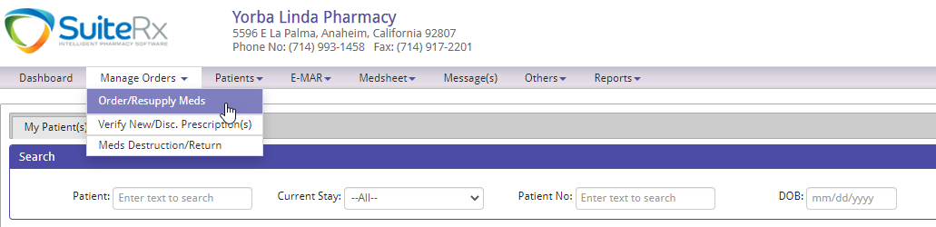
- You can order refills through Order/Resupply Meds, just filter by facility and select the Rx’s or click the Refill Request by Rx no. tab and search for the Rx to process the refill request.
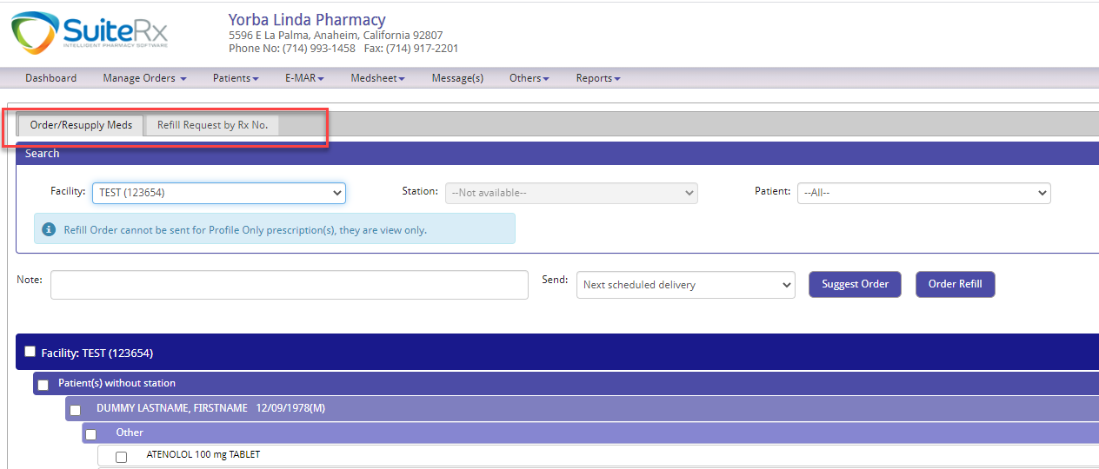

How to look up Delivery Details

- On the top option, click Reports > Delivery Report. This is where you can view and search Deliveries and the details. You can search by facility or by delivery number.
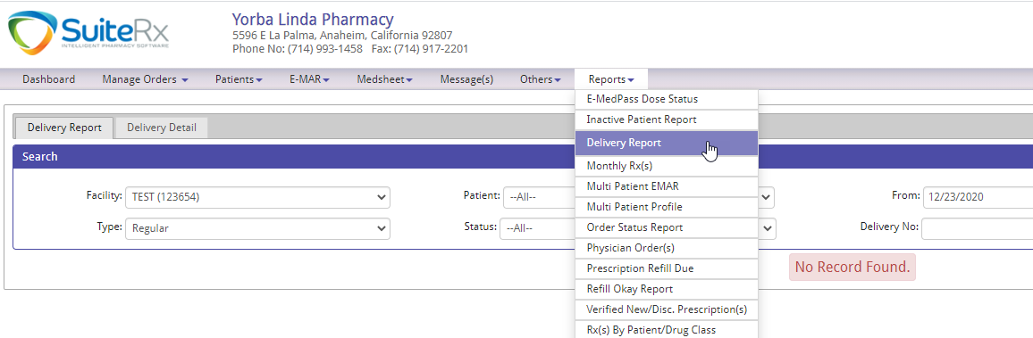

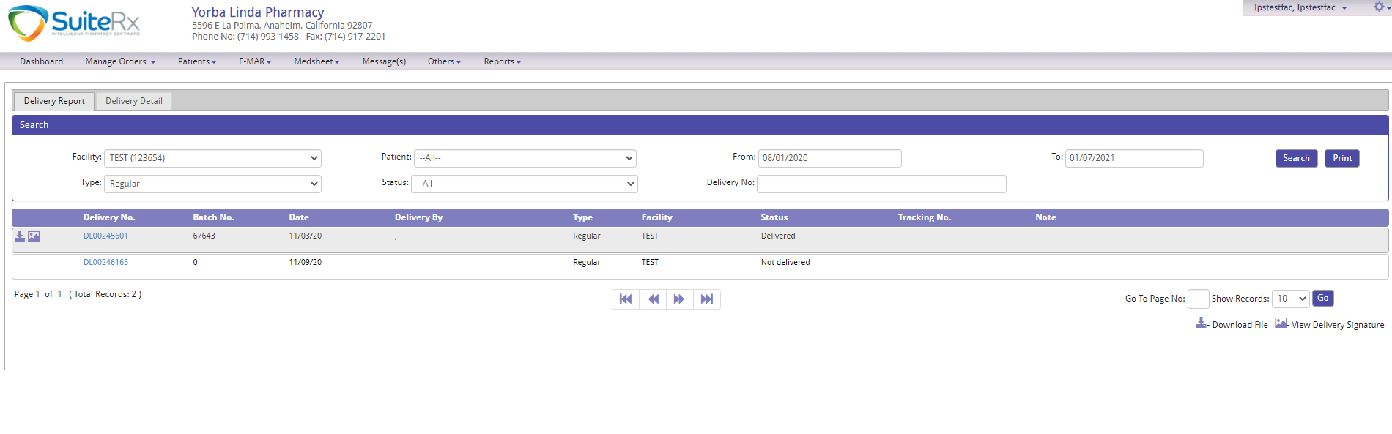

How to View/Print Copies of Prescriptions

- On the top option, click on Patients > My Patient(s).
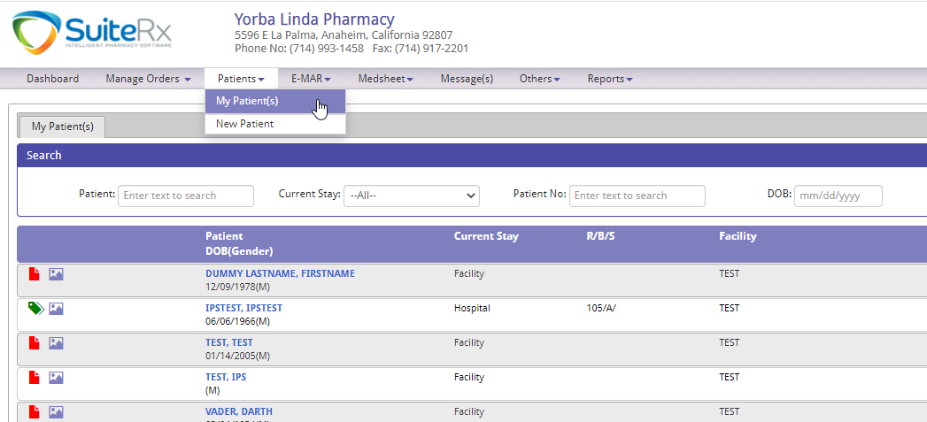
- Click the patient’s name, then click Profile.
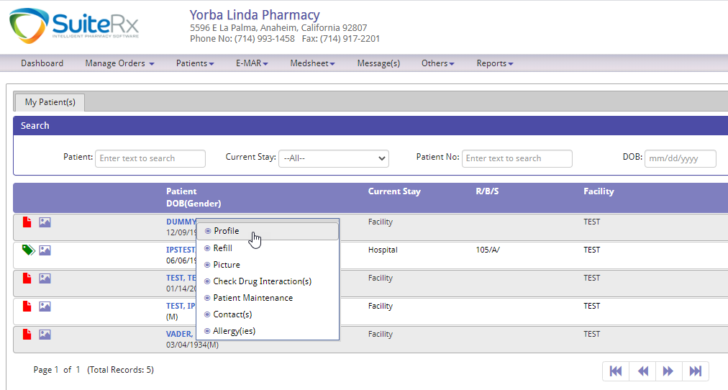

- Profile Detail page will pop up, and here you can click the icon to View the Prescription image, or click the icon to download and print the Prescription image.

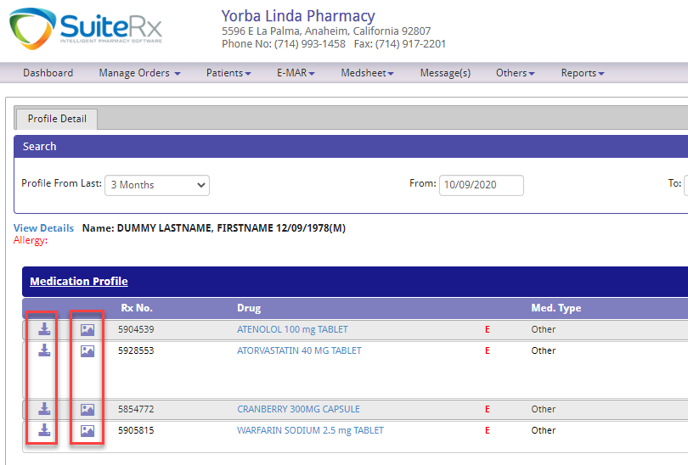

How to see Drug Information/Pictures

- One way is to go to the Profile Detail of a patient, and click the Drug name. It will open up a new window for the drug information.
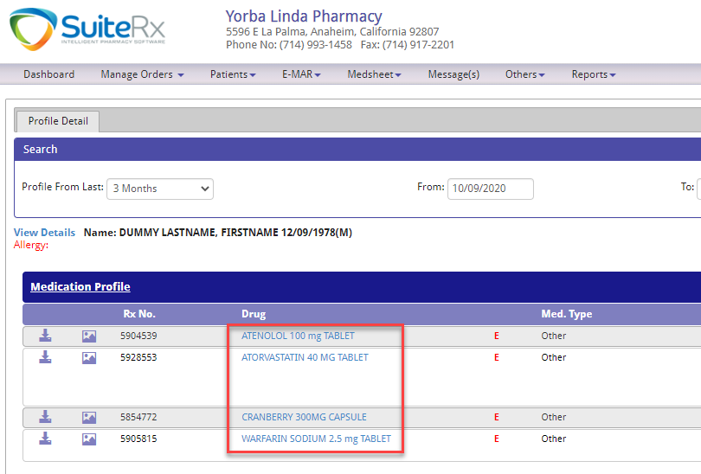

- Another way is to go to Others > Drug Info. Here you can search for the Drug.
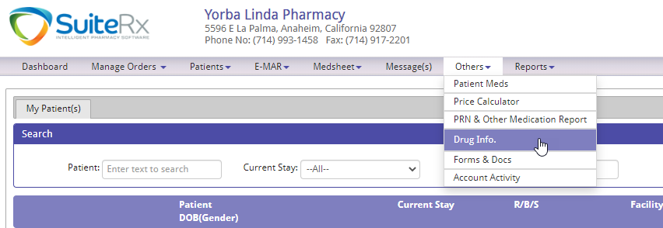

How to send electronic messages to the pharmacy
- On the top option click on Message(s).
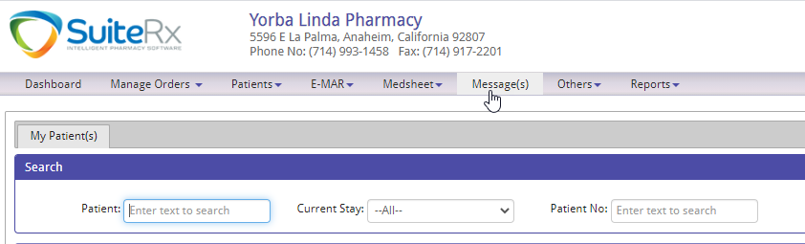
- This works like standard email where you can compose a message and read messages from the inbox.
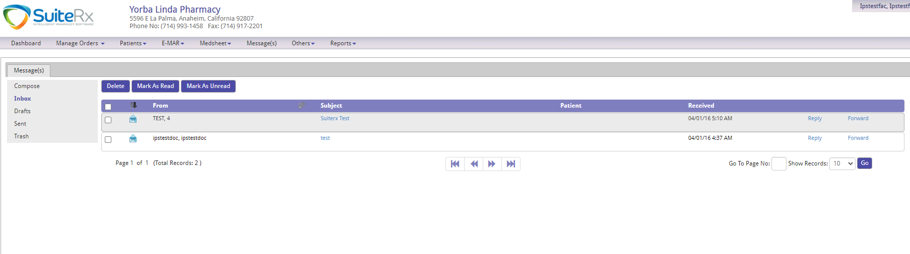
- To send a message to the pharmacy, just click compose and set the recipient to Pharmacy.
